Contents

Loading Data 2

Plot Views 3

Plot Interaction 4

Highlight Point 4

Adjust Text 5

Adding/Removing Points 6

Data Interaction 7

Variants 7

Axes 8

Labels 9

# Loading Data

1. 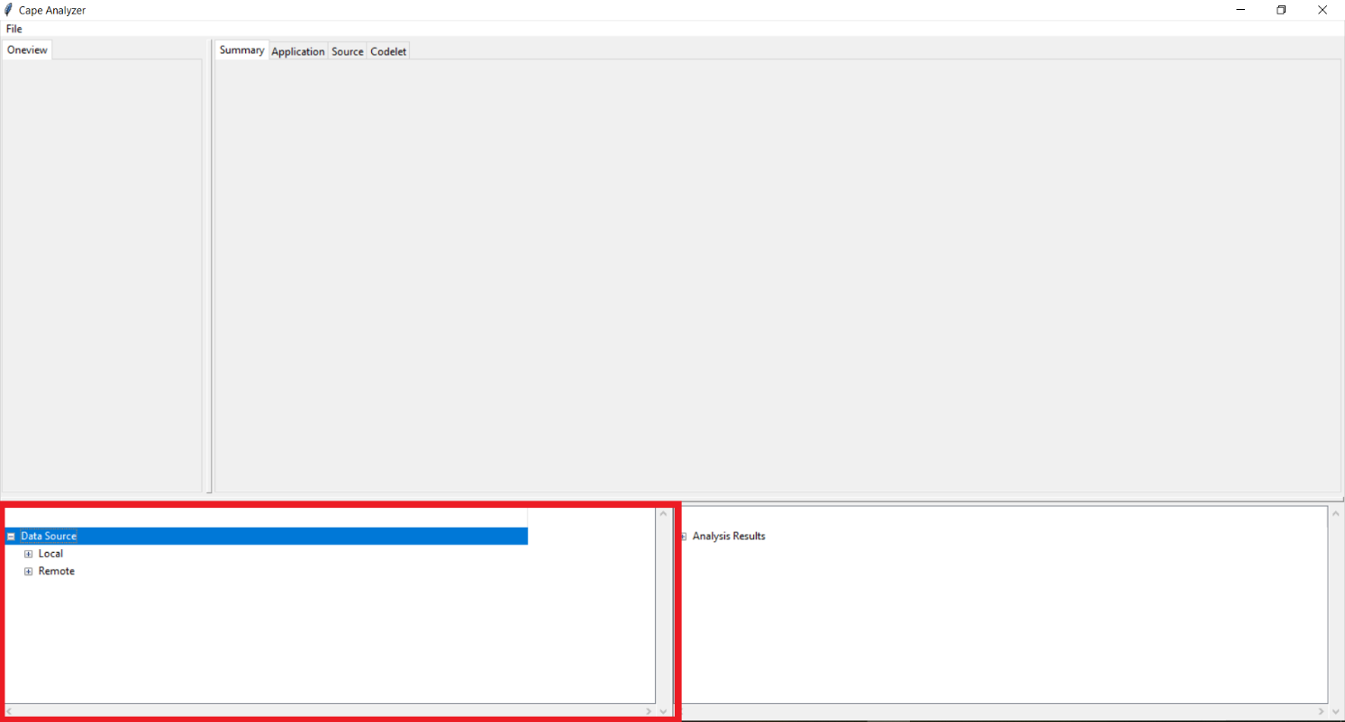Double click the “Data Source” directory in the bottom left panel.
2. You can then browse either locally saved data or remote data. Under the “Local” directory there is a “Previously Visited” directory which contains any data files that you have looked at before. Under the “Remote” directory you can browse UVSQ or UIUC data that you haven’t loaded before.

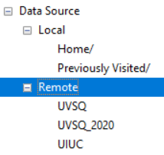

1. Once you have found a file to load, just double click it and wait for the tool to generate the plots.

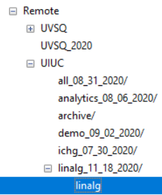

# Plot Views

1. After loading a data file you’ll be presented with the “Summary” plot at the “Codelet” level, which is a basic profile view that shows the percent coverage of each codelet against gigaflops.
2. There are 3 levels of aggregation for the loaded data, “Application”, “Source”, and “Codelet”, with the “Codelet” level showing the most details. To switch between these levels, you can click the labelled tabs at the top left corner of the plot.

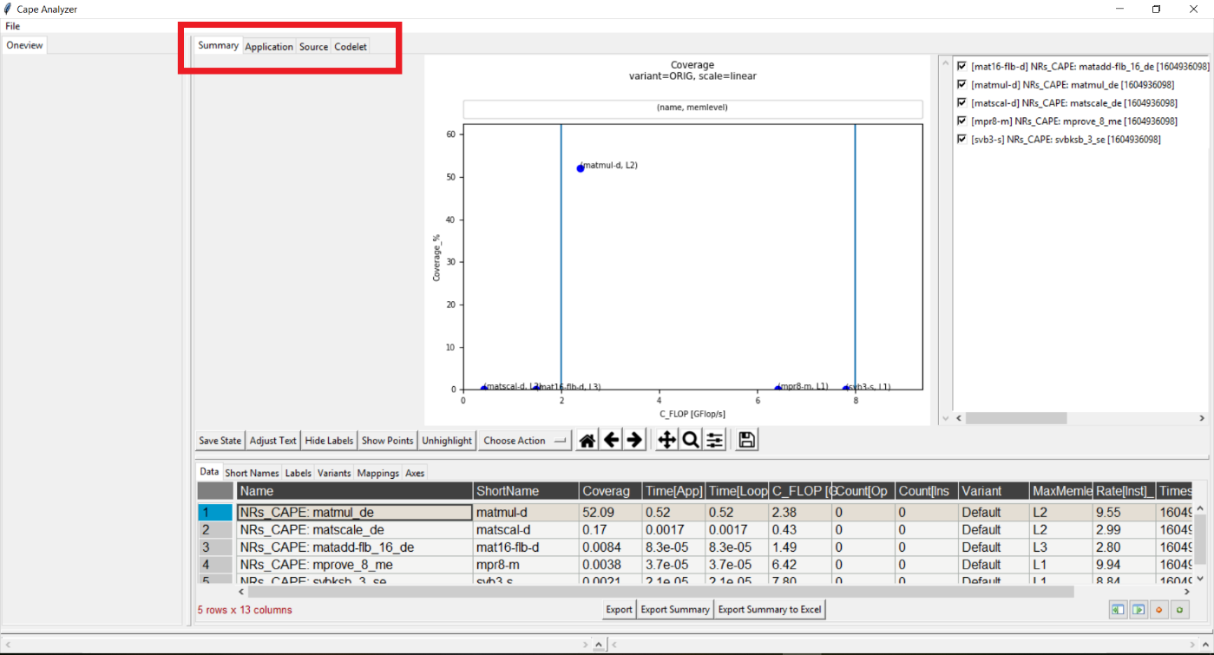

1. Each level has several views that are accessible through the sub-tabs which you can click to view them.

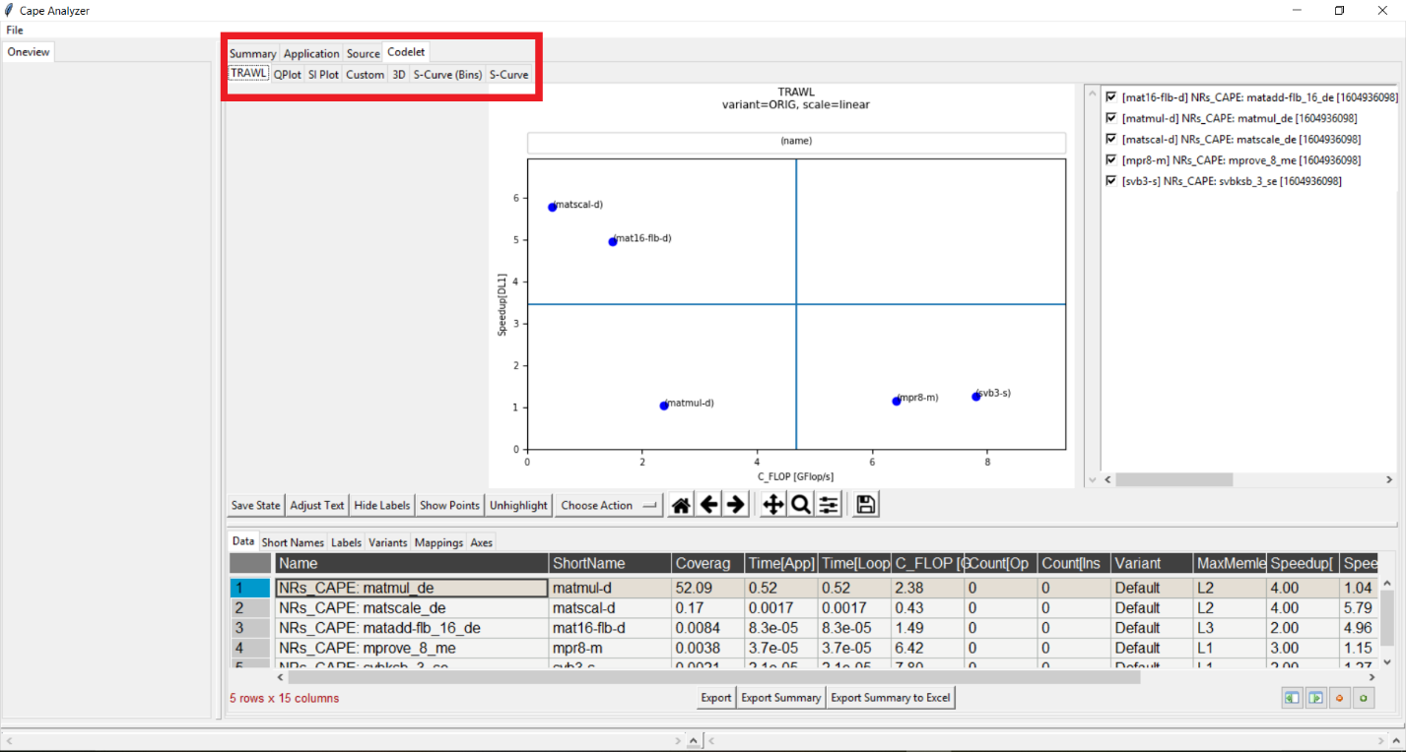

# Plot Interaction

There are several buttons located underneath the plot that allow the user to make filter/highlight data points or manipulate their labels.

## Highlight Point

* Click on the drop-down button that says “Choose Action” and then select “Highlight Point”

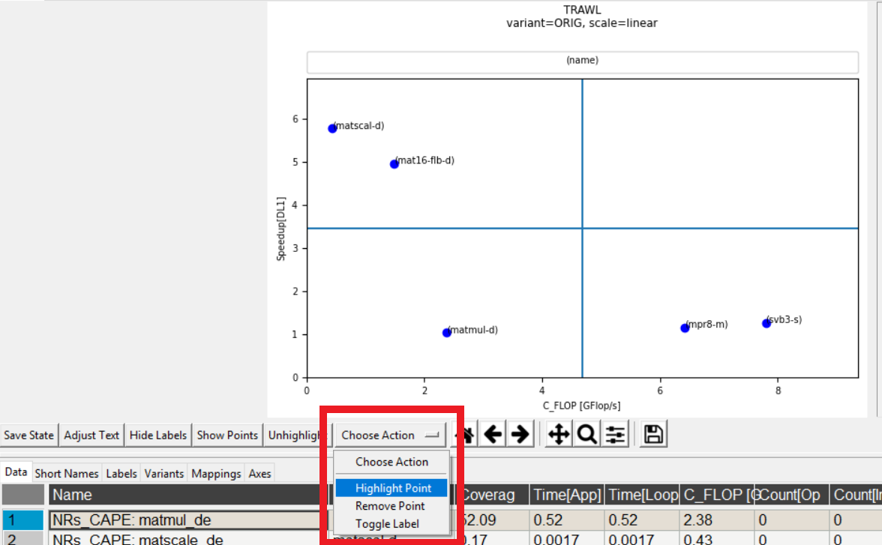

* Next you can click on any data point and it will be highlighted in the current plot and all other plots at the current level. You can then click the same point to unhighlight it.

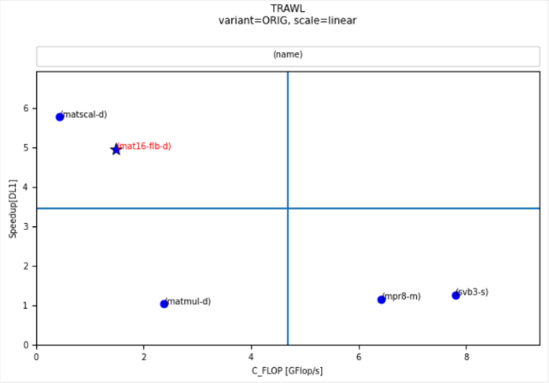

## Adjust Text

* Click on the “Adjust Text” button which will automatically adjust the datapoint labels and add a red arrow from the label to the point.

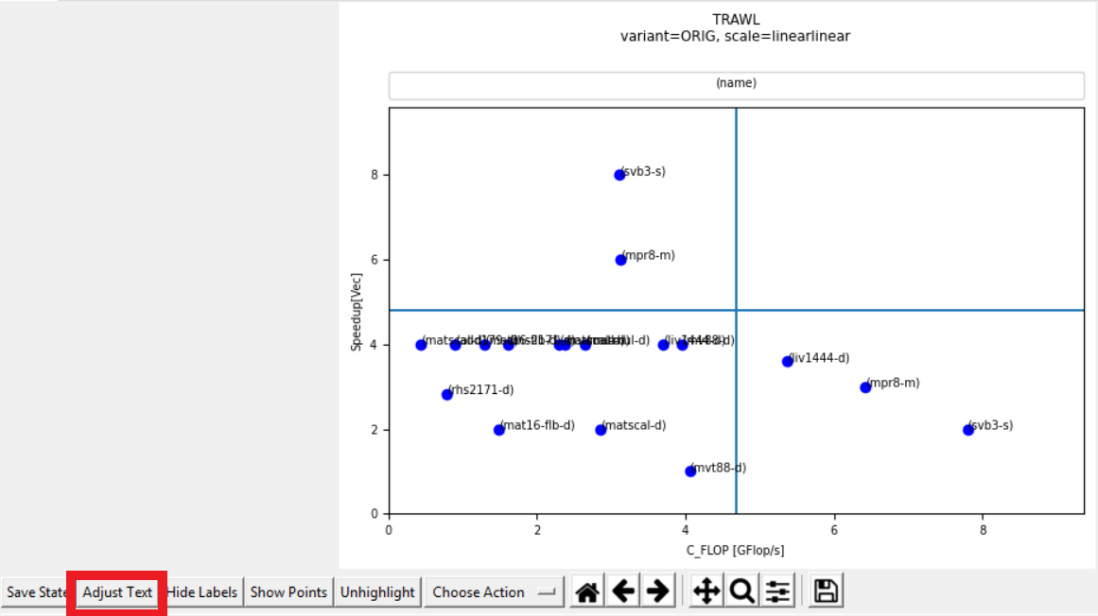

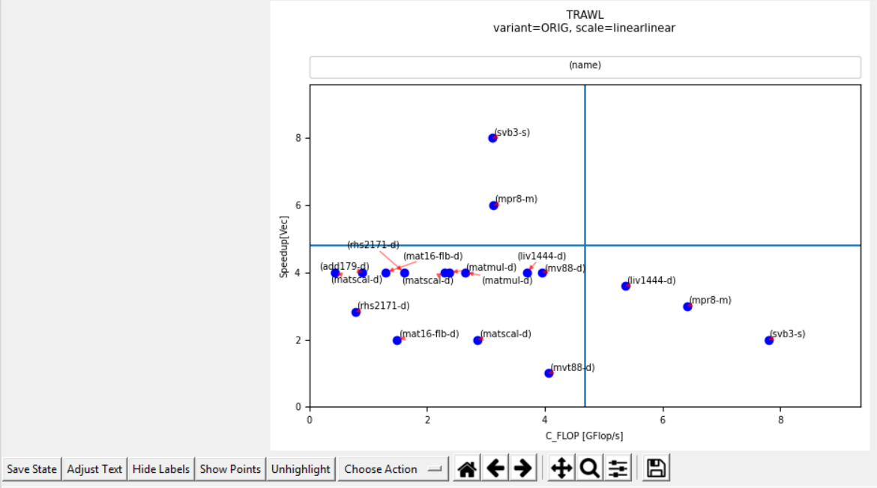

## Adding/Removing Points

* You can remove data points in two ways. One way is to click “Choose Action” and then “Remove Point”, and then you can click on any data point that you’d like to remove.

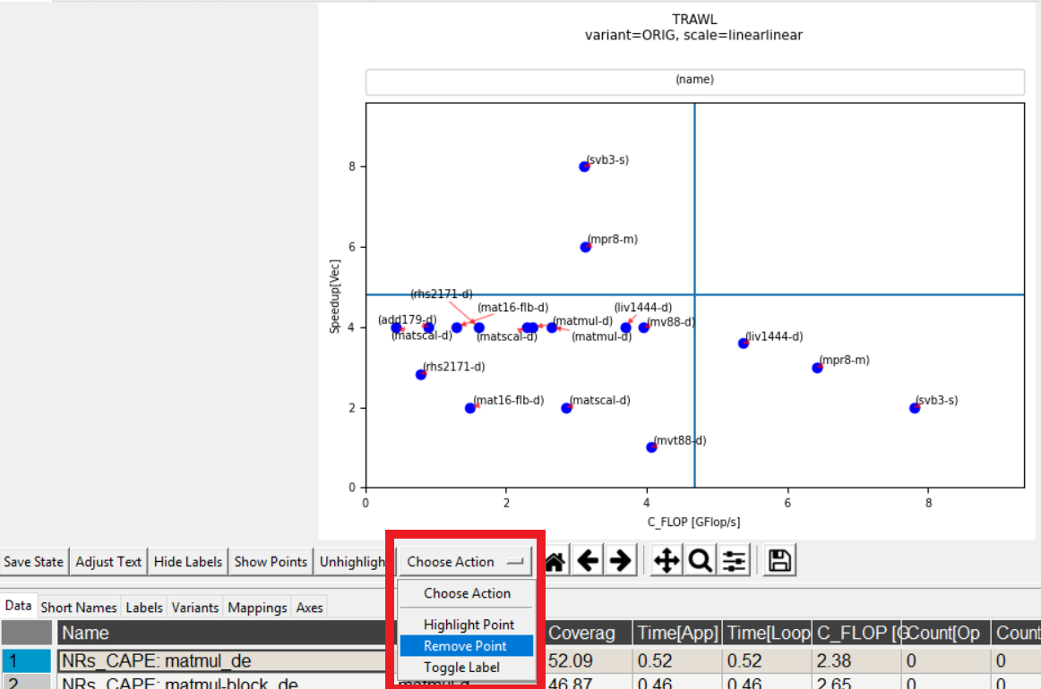

* The other way is to use the checklist to the right of the plot and you can check/uncheck points to add/remove them from the plot. Name format is: [short name] name [timestamp]

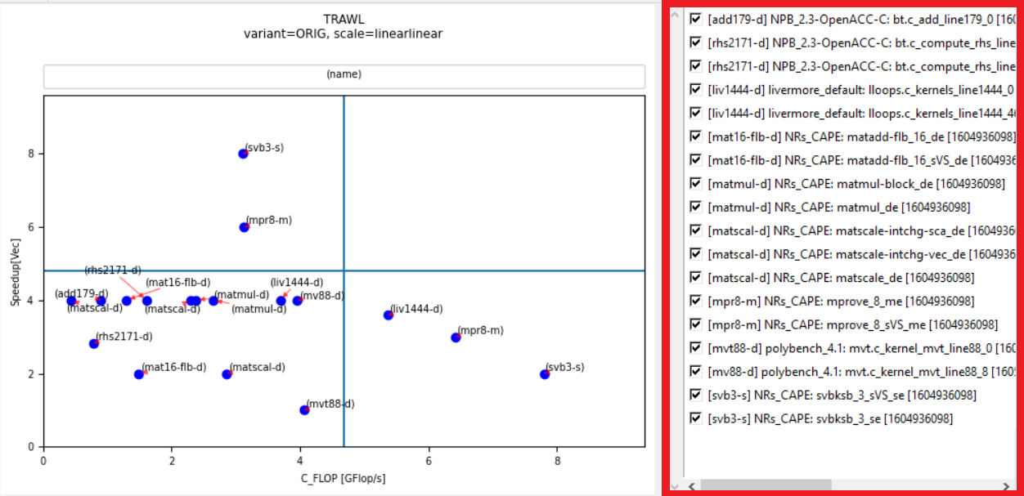

# Data Interaction

There are several tabs underneath the Plot Interaction buttons that allow the user to filter data or change short names, axes, mappings, and label metrics.

## Variants

* When loading a data file, the tool initially only shows the codelets associated with the variant that is most frequent in the data. This variant is generally labelled “Default” or “ORIG” and corresponds with untransformed codelets.
* To see more variants plotted, you can go to the “Variants” tab underneath the plot. Next select the specific variants you’d like to see and then click “Update”

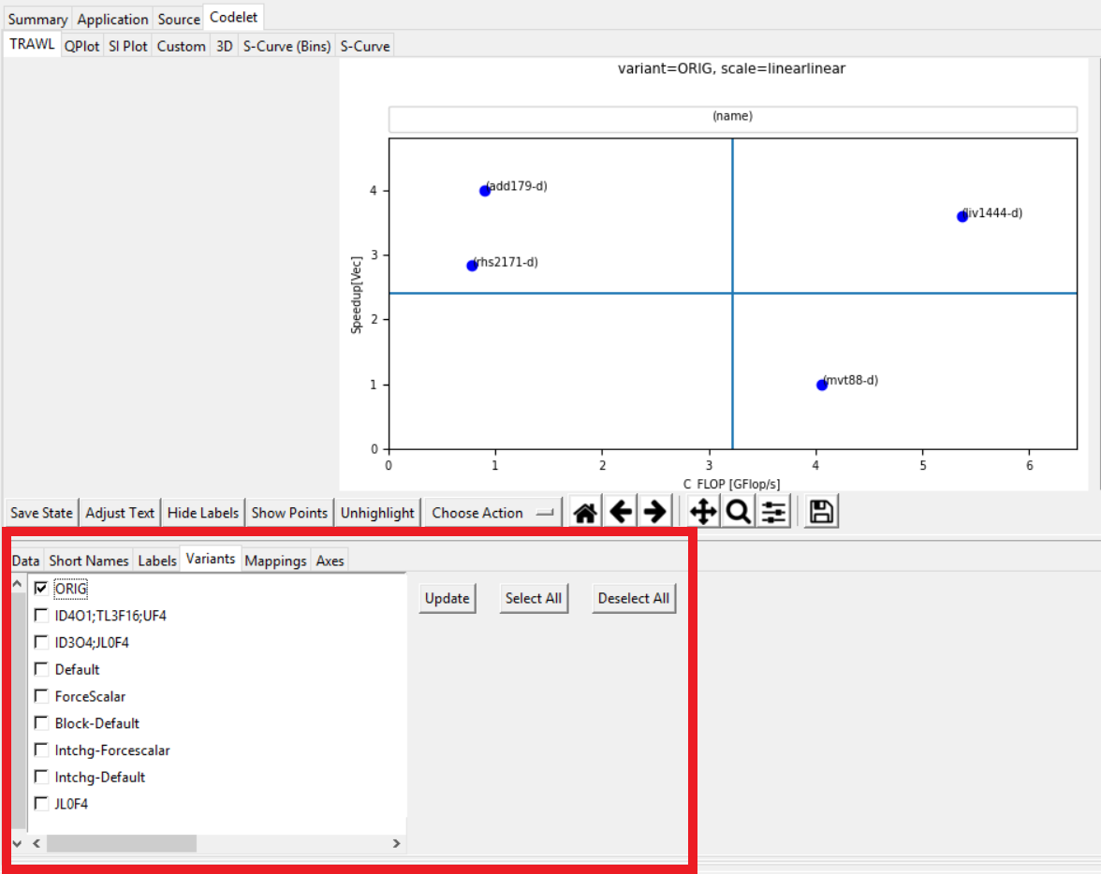

## Axes

* The tool offers the ability to change either the metrics used for the x and y axes as well as the scales.
* First click on the “Axes” tab underneath the plot.

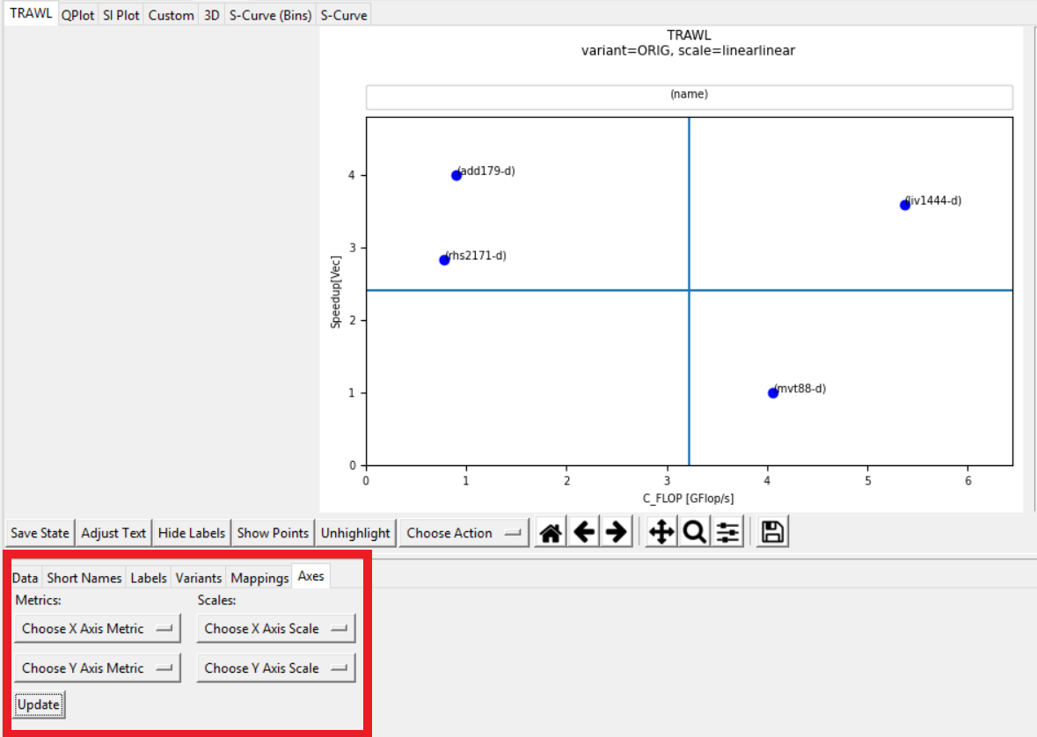

* You can then choose a new metric/scale from the drop down menus and click “Update”. If no metric/scale is selected for some of the 4 options then it will use what is currently plotted.

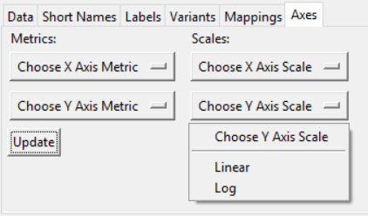

## Labels

* You can add specific metrics to the labels of each codelet through the “Labels” tab under the plot. You can select up to 3 metrics to append to the label of a codelet and then click “Update”.
* Click “Reset” to bring the labels back to the default.

